2 project –

1🡪 Spring and hibernate Integration

2 -> Restful web service using Spring Boot

RestFul Webservice

**WebService :-** Services which run over the web (internet ) is called web services

ICIC (ATM CARD )-🡪 <-- HDFC ATM Machine

HDFC ATM Machine

Card Number

Pin

Amount 10000

Hdfc send request to icici ---🡪

HDFC developer (java) -🡪 icici (java) to take the request and perform operation and send response

[**http://localhost:8080/createEmployee?fname=fusion&lname=tech**](http://localhost:8080/createEmployee?fname=fusion&lname=tech)

AXIS 🡪 Work on .NET

RequestMapping

RequestParam

Response

Http protocol 🡪 language independent

ICIC

(.net)

KOTAK

(python)

AXIS

(java)

HDFC

Send

Request

(java )

HTTP Request

HTTP Response

SOAP :- old ( mode of transfer of data is xml)

<Student>

<fname>fusion</fname>

<lname>tech</lname>

</Student>

REST FUL webservice:-

Json , text , file, xml

{

“fname”:”fusion”,

“lname”:”tech”

}

Provider and Consumer has a contract

contract has a end point information

REquestMapping and Requst Param

@RequestMapping("/editemp")

public ModelAndView editEmployee1(@RequestParam("id") int id) {

/editemp?id =5 🡪 get

@RequestMapping("/getAllEmployee")

public ModelAndView getAllEmployee() {

/getAllEmployee 🡪 get

Request -> Base URL (port number )

Requst Mapping 🡪

[**http://localhost:8080/createEmployee?fname=fusion&lname=tech**](http://localhost:8080/createEmployee?fname=fusion&lname=tech)

**<http://localhost:8080/validateUser?atmnumber=1234566&pinCode=2345 (post)>**

Response :- Http Response

Success

Failure

Serverdown

RequstNotCorrect ATMNUMNER get

200 🡪 success case

400🡪 404 request for found, 405 🡪 method not support

300

500 🡪 server releted

HTTP REQEST method

GET 🡪 read operation

POST 🡪create operation   
PUT 🡪 update operation   
DELETE 🡪 delete operation

PATCH 🡪 update operation

Rest Ful 🡪 Develop using Spring Boot

Test using post man

SB is used to build stand-alone and production ready spring application

Spring MVC hello World

1. Dynamic web project
2. Web.xml
3. Controller
4. Hi-servelet.xml
5. ViewResolver

DispatcherServlet

Tomcat

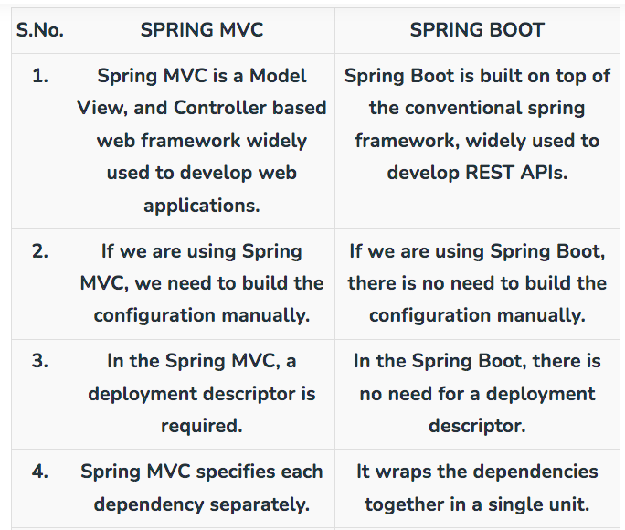

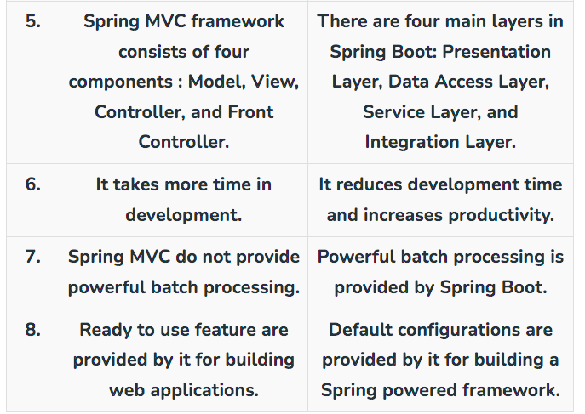

SB provide the tomcat server by default

1. **Tomcat**
2. Jetty
3. Undertow

STS 🡪 Spring tool suite 🡪 it is build on the top on eclipse

Pivotel

# Current version is 3.1.1

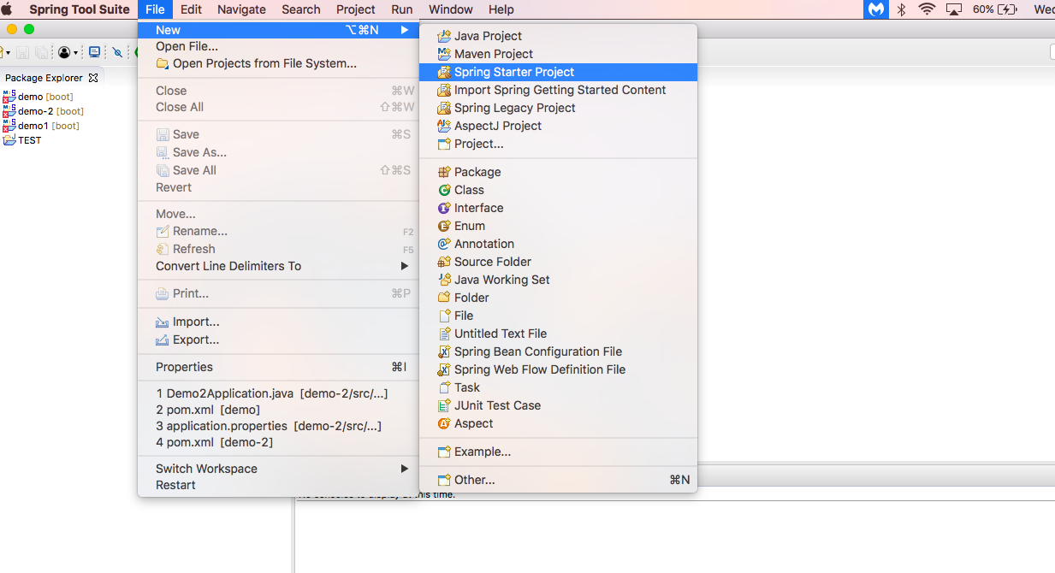

MAVEN 🡪 Project build tool

Java code(1 gb ) + Lib (2 gb) -🡪 3gb

Java code (1 gb )

Jar 🡪 java archive

com.tech.controller.StudentController

com.tech.service.StudentService

com.tech 🡪 group id

controller 🡪 artifact id

service 🡪 artifact id

jar -🡪 java archive

war -🡪 web archive (java+ jsp/html/css)

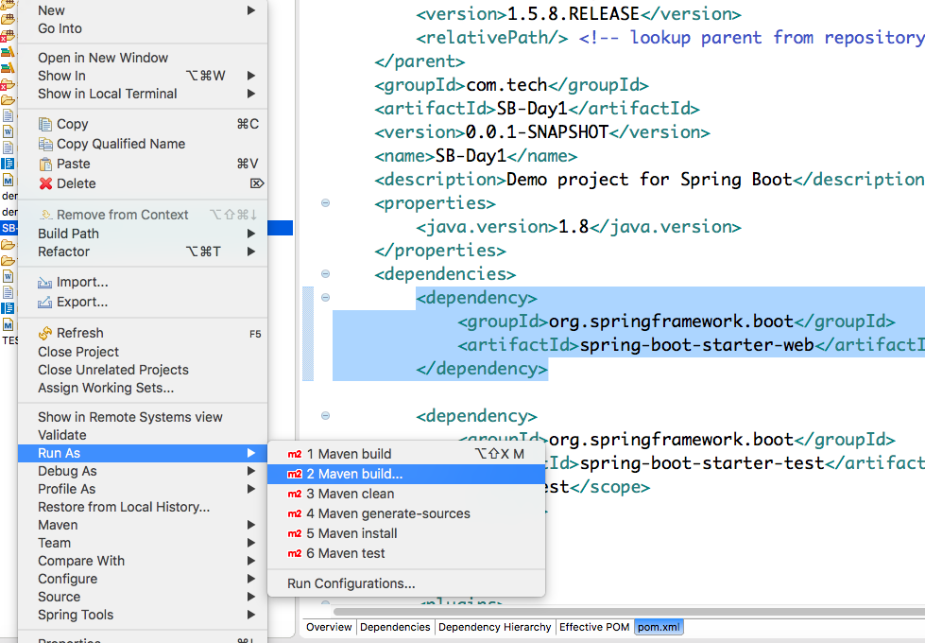

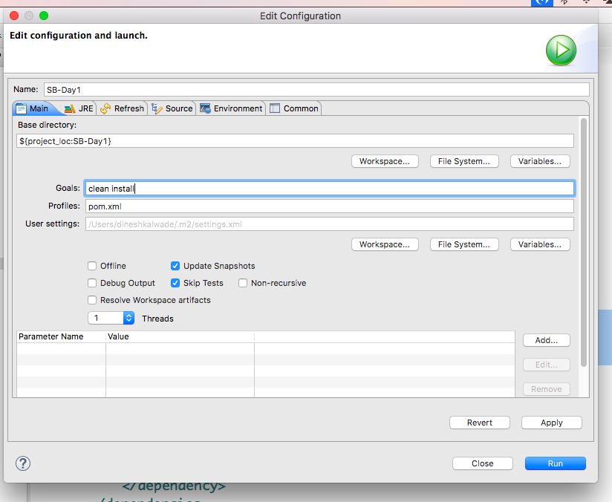

clean install 🡪 it download the jars which are mentioned in pom.xml in local

.m2 folder ( c drive)

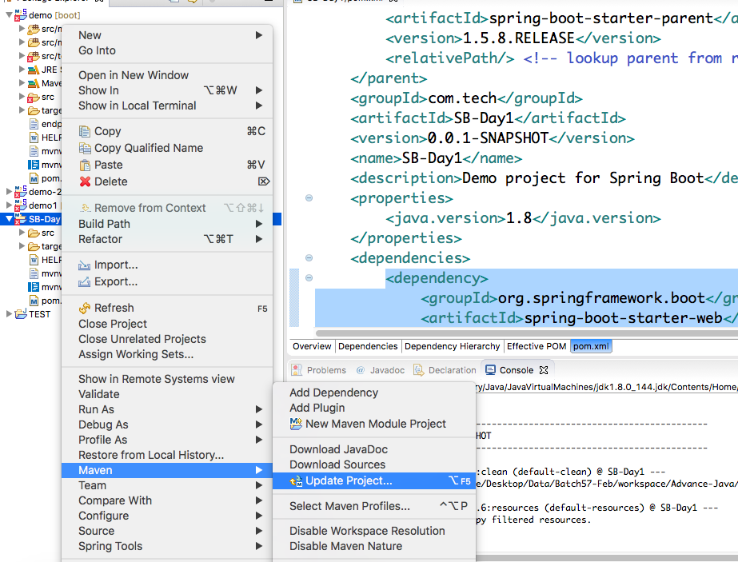

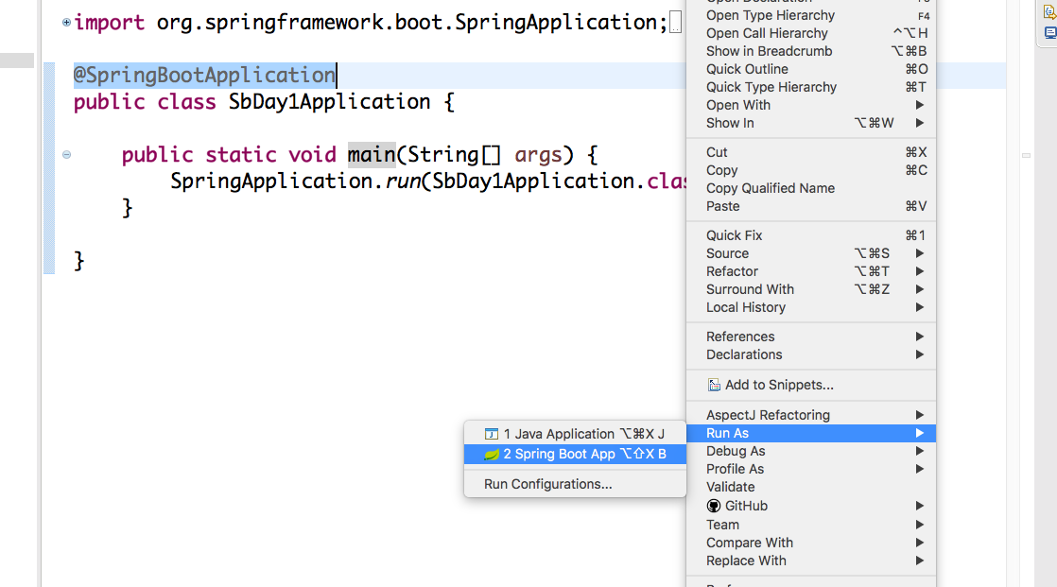

<https://start.spring.io/>

@SpringBootApplication 🡪 most import in SB

@SpringBootConfiguration

@EnableAutoConfiguration

@ComponentScan(excludeFilters = {

@Filter(type = FilterType.***CUSTOM***, classes = TypeExcludeFilter.**class**),

@Filter(type = FilterType.***CUSTOM***, classes = AutoConfigurationExcludeFilter.**class**) })

@RequestMapping(value = "/getName1") 🡪 it gets call by any method

**@RequestMapping(value = "/getName", method = RequestMethod.GET)**

it will call only get request , other than get it will give below error

{

"timestamp": 1689216828460,

"status": 405,

"error": "Method Not Allowed",

"exception": "org.springframework.web.HttpRequestMethodNotSupportedException",

"message": "Request method 'POST' not supported",

"path": "/getName"

}

both are same

@GetMapping("/getName")

@RequestMapping(value = "/getName", method = RequestMethod.GET)

http://localhost:9099/getName?**name**=Fusion

@RequestMapping(value = "/getName", method = RequestMethod.GET)

public String getName(@RequestParam("**name**") String name1) {

System.out.println("inside getName()->" + name1);

return "Hello " + name1;

}

{

"timestamp": 1689217528276,

"status": 400,

"error": "Bad Request",

"exception": "org.springframework.web.bind.MissingServletRequestParameterException",

"message": "Required String parameter 'name' is not present",

"path": "/getName"

}

http://localhost:9099/getCourse/python

@RequestMapping(value = "/getCourse/{cname}")

public String getCourse(@PathVariable("cname") String cname)

{

System.out.println("inside getCourse()->" + cname);

return "welcome to teching "+cname;

}

@RequestParam is used to extract *query parameters*

http://localhost:9099/getName?**name**=Fusion

**while @PathVariable is used to extract data right from the URI:**

http://localhost:9099/getCourse/python

multiple input values

http://localhost:9099/getName2?fname=Fusion&lname=tech

<http://localhost:9099/getCourse2/java/2000>

http://localhost:9099/getCourse2/20000/java

GET 🡪 retrieve

POST 🡪 create

Delete 🡪 delete

PUT 🡪 update

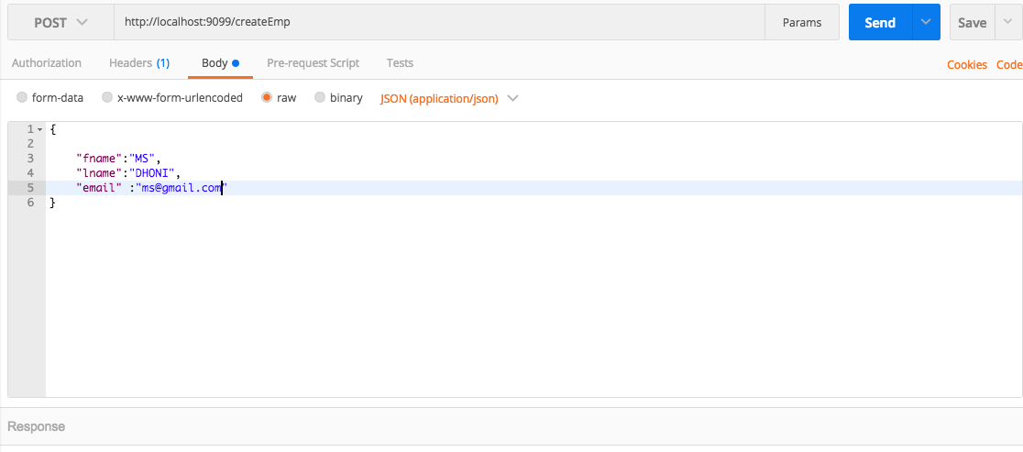

{

"fname":"ROHIT",

"lname":"SHARMA",

"email" :"rohit@gmail.com"

}

RequstParam

PathVariable

@requstBody

@getmapping, @postmapping , @putmapping , @deletemapping

http://localhost:9099/updateEmp

http://localhost:9099/deleteEmp/11

http://localhost:9099/createEmp

{

"fname":"ROHIT",

"lname":"SHARMA",

"email" :[rohit@gmail.com](mailto:rohit@gmail.com)

}

<http://localhost:9099/getCourse2/20000/java>

http://localhost:9099/getName2?lname=Dhoni&fname=MS